Assignment # 35-38  
JAVASCRIPT

Module A  - Mobile & Cloud Computing

**FUNCTIONS**

# **| FUNCTIONS|**

1. Create a block of code that you can use several times.
2. Write a function that displays current date & time in your browser.
3. Write a function that takes first & last name and then it greets the user using his full name.
4. Write a function that adds two numbers (input by user) and returns the sum of two numbers.
5. **Calculator:**  
   Write a function that takes three arguments num1, num2 & operator&compute the desired operation. Return and show the desired result in your browser.
6. Write a function that squares its argument.
7. Write a function that take start and end number as inputs & display counting in your browser.
8. Write a function that writes variable length arguments list in your browser.
9. Write a function that accepts any number of arguments & find largest of the number.
10. Write a function that calculates the area of a rectangle.  
    A = width * height  
    Pass width and height in following manner:
    1. Arguments as values
    2. Arguments as variables
11. Write a function that receives an array & returns the sorted array.
12. Write a function that takes numbers array, sums its elements & returns the sum.
13. Execute & monitor the output of following JS program:  
    varparam = function inner() {   
    return typeof inner;   
    }  
    alert(param());
14. Write a function that computes power of a number. E.g. 23is 8.
15. Write a function that simulates a dice & returns a random dice value.
16. Write a JavaScript function that reverse a number.   
    Example x = 32243;  
    Expected Output : 34223
17. Write a JavaScript function that checks whether a passed string is palindrome or not?  
    A palindrome is word, phrase, or sequence that reads the same backward as forward, e.g., madam.
18. Write a JavaScript function that accepts a string as a parameter and converts the first letter of each word of the string in upper case.   
    Example string: 'the quick brown fox'   
    Expected Output : 'The Quick Brown Fox'
19. Write a JavaScript function that accepts a string as a parameter and find the longest word within the string.   
    Example string: 'Web Development Tutorial'   
    Expected Output : 'Development'
20. Write a JavaScript function that accepts a string as a parameter and counts the number of vowels within the string.

Example string: 'The quick brown fox'   
Expected Output : 5

1. Write a JavaScript function which accepts an argument and returns the type.   
   Note : There are six possible values that typeof returns: object, boolean, function, number, string, and undefined.
2. Write a JavaScript function to extract unique characters from a string.  
   Example string: "thequickbrownfoxjumpsoverthelazydog"  
   Expected Output: "thequickbrownfxjmpsvlazydg"
3. Write a JavaScript function that accepts two arguments, a string and a letter and the function will count the number of occurrences of the specified letter within the string.   
   *Sample arguments*: 'JSResourceS.com', 'o'   
   Expected output : 2
4. **The Age Calculator**

Forgot how old you are? Calculate it!

* Write a function named calculateAge that:
  + takes 2 arguments: birth year, current year.
  + calculates the 2 possible ages based on those years.
  + outputs the result to the screen like so: "You are either NN or NN"
* Call the function three times with different sets of values.
* **Bonus**: Figure out how to get the current year in JavaScript instead of passing it in.  
    
  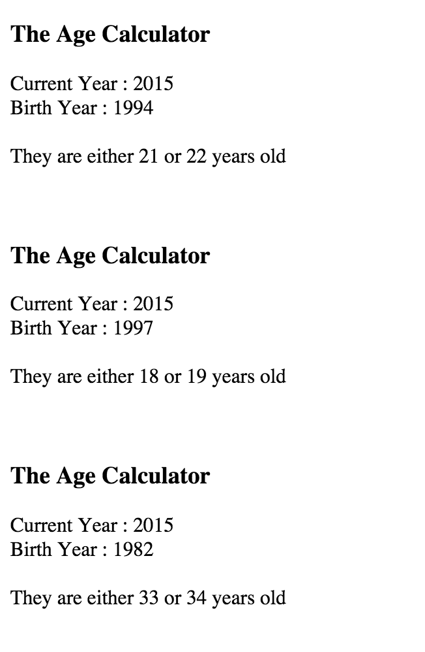

1. **The Lifetime Supply Calculator**

Ever wonder how much a "lifetime supply" of your favorite snack is? Wonder no more!

* Write a function named calculateSupply that:
  + takes 2 arguments: age, amount per day.
  + calculates the amount consumed for rest of the life (based on a constant max age).
  + outputs the result to the screen like so: "You will need NN to last you until the ripe old age of X"
* Call that function three times, passing in different values each time.
* **Bonus**: Accept floating point values for amount per day, and round the result to a round number.  
  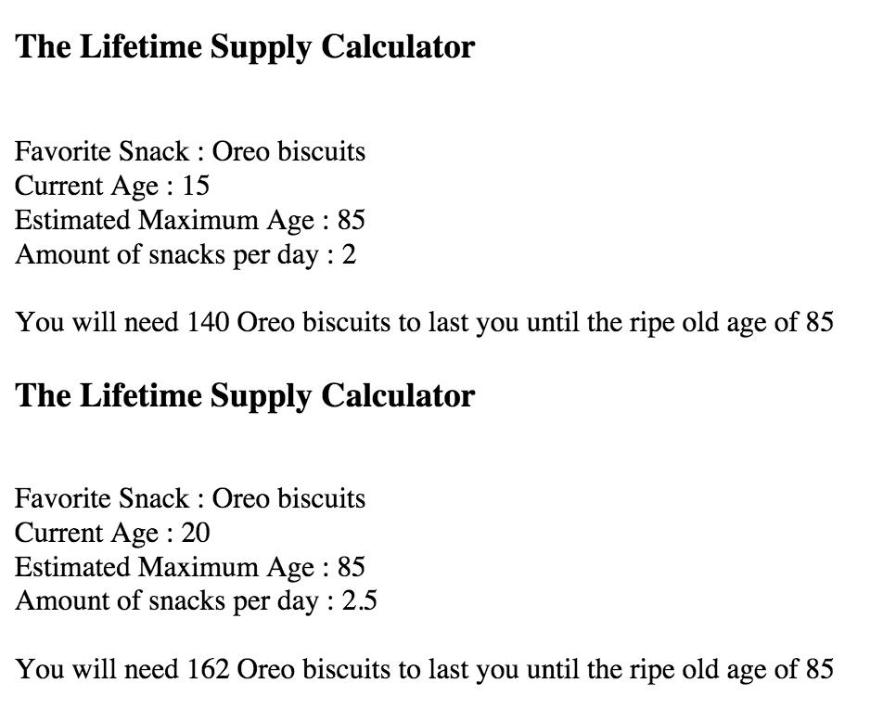

1. **The Geometrizer**

Create 2 functions that calculate properties of a circle, using the definitions here.

Create a function called calcCircumference:

* Pass the radius to the function.
* Calculate the circumference based on the radius, and output "The circumference is NN".

Create a function called calcArea:

* Pass the radius to the function.
* Calculate the area based on the radius, and output "The area is NN".

1. **The Temperature Converter**

It's hot out! Let's make a converter based on the steps here.

Create a function called celsiusToFahrenheit:

* Store a celsius temperature into a variable.
* Convert it to fahrenheit and output "NN°C is NN°F".

Create a function called fahrenheitToCelsius:

* Now store a fahrenheit temperature into a variable.
* Convert it to celsius and output "NN°F is NN°C."

**--END--**